Misusing the internet  You have important rules to follow when using the internet. If you don’t follow these, there can be serious consequences. If you do something illegal, it might even involve the police.  Our school has an Acceptable Use Agreement which tells you what is expected of you. Make sure you read this and understand what you have to do before you use the internet or any device.  ‘Think before you click’  Sometimes, you can put yourself at risk of harm without even realising it -- always think before you click on any website.  Some websites might look trustworthy, but can have harmful links or attachments which can give your device a virus. These can also access your personal details and pass them on to other people.  Websites might also have harmful and nasty content on them which can be offensive. Make sure you only use websites which you know are safe.  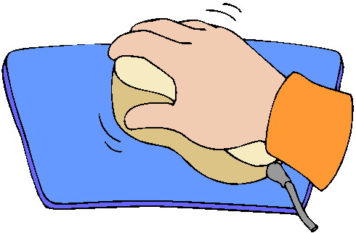 | Staying safe: top tips  Use the tips below to help you stay safe online and make sure you’re using the internet correctly:  - Treat others how you would like to be treated. If you wouldn’t say something to someone in person, don’t say it online either.  - Make sure you’re aware of how your messages might come across to others.  - Don’t spread rumours or gossip about people.  - Don’t post things that will upset someone. Make sure you think before you post anything.  - Respect other people’s privacy.  - Use websites you know are safe.  - Don’t talk to anyone you don’t know, or arrange to meet them.  - Keep an eye out for unusual pop-ups, adverts or downloads. Don’t open them if you think they aren’t trustworthy.  - Don’t give out personal information about you, your friends or your family to anyone you don’t know.  - Only use social networking sites that you are old enough to use – age limits are there for a reason.  - Speak to an adult if something worries you or makes you feel uncomfortable.  If you want to talk about anything in this leaflet, see your teacher, who will be happy to go through things with you. Please make sure you keep this leaflet safe! |  | March 2017  Name of school  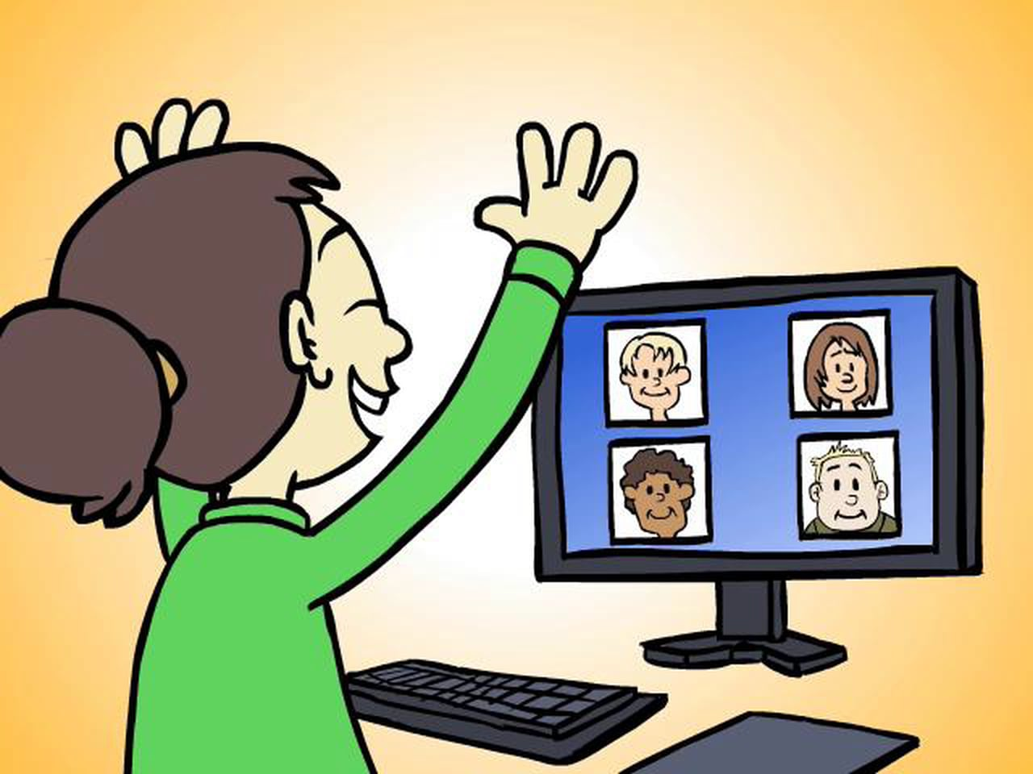  - E-safety for pupils: are you staying safe online?  Why is it important?  We all like to use the internet and talk to others online, but do you know the rules you need to follow to keep safe?  There are many risks from using the internet. Some of these include cyber bullying, grooming, breaching privacy and losing personal information, but, there are many more.  Staying safe online isn’t just important for you – when using sites, you need to think about what you’re saying about, or to, other people.  Ask yourself:  - Do you know how to protect yourself and others online?  - Do you know what the risks are?  - Do you know what to look out for?  - Do you know who to report concerns to?

The risks explained  - Cyber bullying – bullying others online; this can be posting or sending unkind messages, photos and videos, for example.  - Grooming – someone trying to gain trust from a person so they can sexually abuse or exploit them.  - Sexting – sending a sexual or inappropriate text, image or video.  - Exploitation – a type of sexual abuse where someone might trick another person by making them believe they are in a loving relationship. This can also involve giving gifts, money or affection in return for sexual activities.  - Radicalisation – pressurising others into supporting extreme religious beliefs or hate crime.  Posting personal information, such as your full name, address and phone number, is also risky as this can be lost and someone else can have access to it. This also includes pictures and videos, and not just of yourself, but of others, too.  Remember: these are only some of the most important risks.  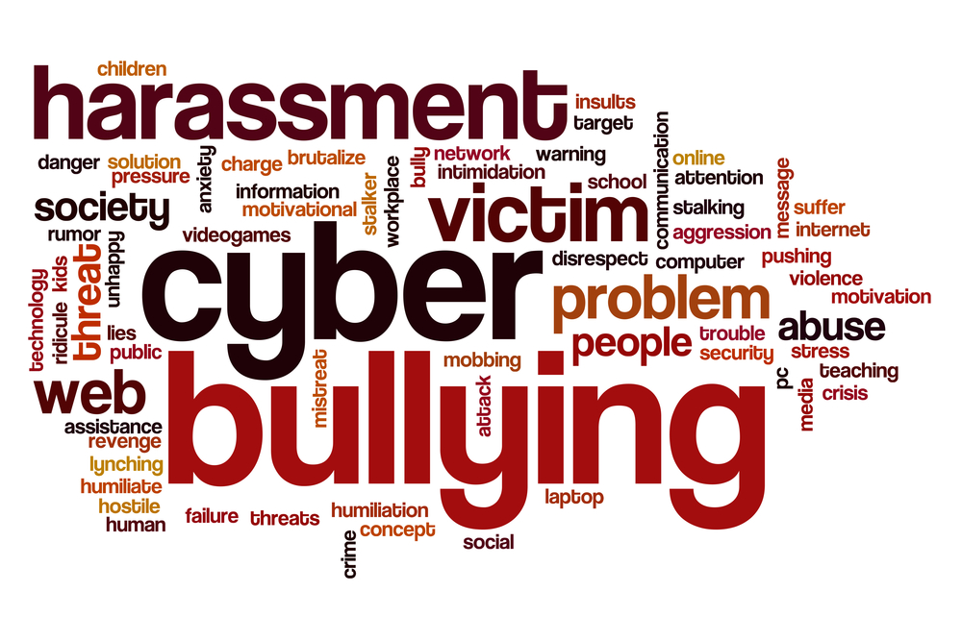  There are plenty more and you need to use your judgement to decide what is safe and what’s not. | What do I need to look out for?  Some of the most common indicators that your safety is at risk include if someone:  - Asks you for your address, phone number, or common places you visit.  - Asks to keep their chats with you private.  - Shares information, pictures or videos with you and tells you not to tell anyone else.  - Sends you pictures or videos which make you feel uncomfortable, scared, or worried about showing them to anyone else.  - Asks you to send pictures or videos of yourself, particularly those which make you feel uncomfortable.  - Asks you to use video chat or a webcam in a way which makes you feel uncomfortable or worried.  - Pays you lots of compliments and offers or gives you gifts.  - Tells you that you will get into trouble if you tell an adult about them or your conversations.  What about other people?  You can also spot the signs of risky behaviour in your friends or people close to you. Keep an eye out for the following signs and report it to someone if you are worried:  - Using technology devices a lot, e.g. mobile phones  - Going online during the night  - Being secretive about what they are doing  - Acting differently in their behaviour, clothes and friends  - Getting gifts or money from unknown people | I have a concern, what do I do?  It’s really important that if you feel threatened you speak to someone. This could be your parents, your teachers or your friends – mostly importantly, someone you trust.  You might want to ask a staff member to sit with you in a quiet area of the school so you can tell them in private. Staff members will not ask you questions, but will listen to what you want to say. It’s important not to be scared to speak to someone.  If you tell someone, you can get the right help and support, and we can make sure that you feel safe again. This doesn’t have to be a concern about your safety, it could be that someone has told you something that’s made you worried, or you’ve noticed the signs talked about before.  Remember: If you tell a staff member, they can’t promise not to tell anyone else.  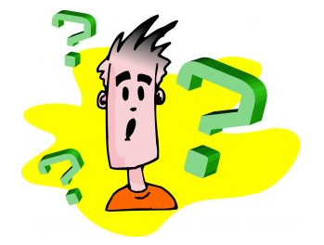  This is because your safety, or the safety of someone else, always comes first. If you or another person is likely to be at serious risk of harm, staff members must tell someone so we can make sure you, or your friend, get the help needed.

