15th July 2025

**Leadership restructure 2025 onwards**

Dear Parents and Carers,

I would like to inform you of some key changes regarding our leadership team from September 2025 onwards. The Trust has recently grown and we now have seven primary schools in our family of schools. With some changes to Trust staffing centrally, a review of our primary executive leadership arrangements took place which has led to me being appointed as Director of Primary Education for our Trust – HFCMAT, replacing my Executive Headteacher role. I’m delighted to inform you that Mrs LeFeuvre has been appointed as substantive Headteacher at St Bernard’s, replacing her existing Head of School role. With the school in a strong position, this is the ideal time for Mrs LeFeuvre to continue to move the school forward with our experienced leadership team and wonderful staff in support.

Mrs Brickland will continue as SENDCo and Miss Senior as Key Stage Lead. To support another school in our Trust on an interim basis, Miss Reid will be onsite less in the autumn term. In her absence, Mrs Thomson will continue as interim Assistant Head.

In my new role, I will continue to work strategically with the school and will be onsite on a regular basis. St Bernard’s has been a huge part of my life for the last 20 years – it’s a special community and I’m proud to continue to be a part of the school's journey, albeit in a more strategic role. Under Mrs LeFeuvre’s leadership and with the support of the Trust, the future is exciting for the school and we’re looking forward to working with you to make St Bernard’s the best it can be.

Yours Faithfully,

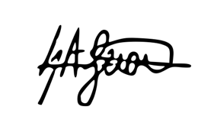

Executive Headteacher